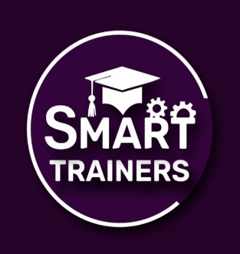
SMART TRAINERS
Elsa Qazi Campus Old Campus
Colony, Thandi Sarak, HYD

Internship Hands-on Task No. 2 Due Date: 17/01/2026 Batch-02 Smart Trainers Marks Assigned: 25
Assignment Submission Instructions:
- Ensure all tasks are finished and correct.
- Save Your File in this format: PDF/MS Word.
- File name: (Your Name)
- Late submissions may not be accepted.
- Submit your assignment on google classroom.

Assignment/Task:
Assignment: Basic Conversational Chatbot
Introduction
In this assignment, you will design and build a simple conversational chatbot using Python. The goal is to help you understand how real chatbots work at a fundamental level by using basic programming concepts such as lists, dictionaries, loops, and conditional statements.
Chatbot Description
Your chatbot will act as a small digital assistant. It will store a set of predefined user inputs and their corresponding responses in a dictionary, for example:
responses = {
"hi": "Hello!",
"hello": "Hi there!",
"how are you": "I am fine, thank you!",
"what is your name": "I am a basic chatbot."
}
Flow of Interaction
Greet the user and ask them to type a message.
Check if the user's input exists in the responses dictionary:
If yes: Display the corresponding response.
If no: Inform the user that the chatbot does not know the answer yet and store the new input in a list for future reference.
Repeat this loop, allowing multiple questions in a session.
Stop the conversation when the user types "bye".
Learning Outcomes
By completing this assignment, you will practice:
Using dictionaries to store question-answer pairs
Using lists to track new or unknown questions
Implementing loops for continuous interaction
Applying conditional logic to control chatbot responses
This exercise provides a hands-on introduction to building interactive programs and understanding how chatbots manage data and conversations.

